

Corner to Corner C2C

Make a slip knot and insert your hook and chain 6

Work a tr into the 4th chain from the hook and then into each of the next 2 chains.

Turn and ch 6

Tr into the 4th ch from the hook and then into the next 2 chains. Your work will look like this:

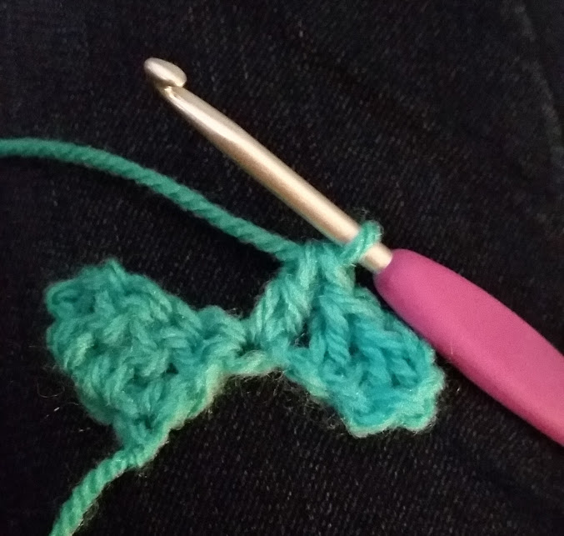

Then you are going to join these two groups of stitches together by ss into the space at the end of your first grouping as shown by my needle in this picture:

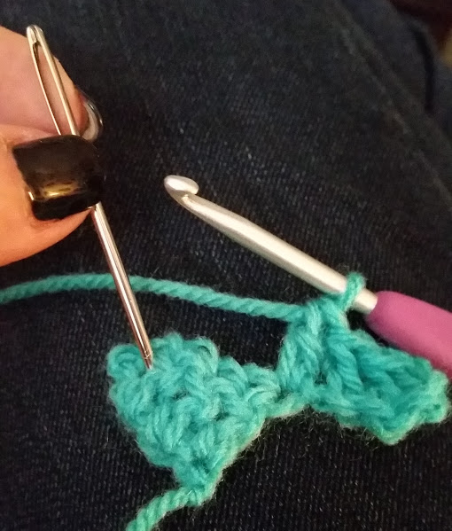

Then chain 3 and insert 3 more tr into the space marked with my needle here:

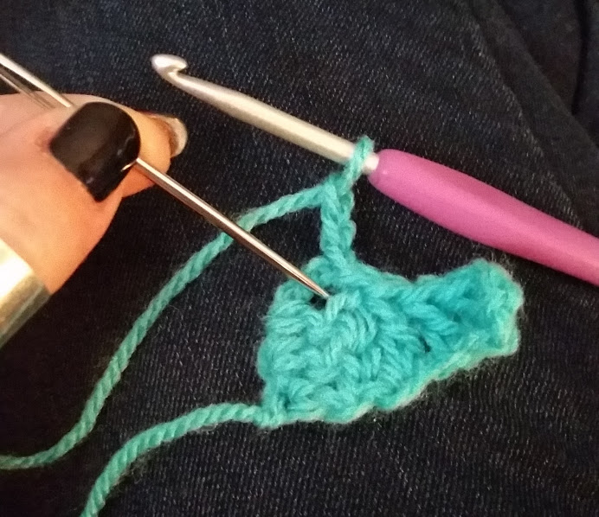

If you are using 1 ball of variegated yarn at this point turn your work and chain 6

If you’re making a stripe version, cast off. Turn your work and Join a new colour into the cast off point with a chain join and chain 6.

Insert a tr into the 4th chain from the hook and then into the next 2 chains.

ss into the space between the end posts of our group from the row below as marked with my needle here:
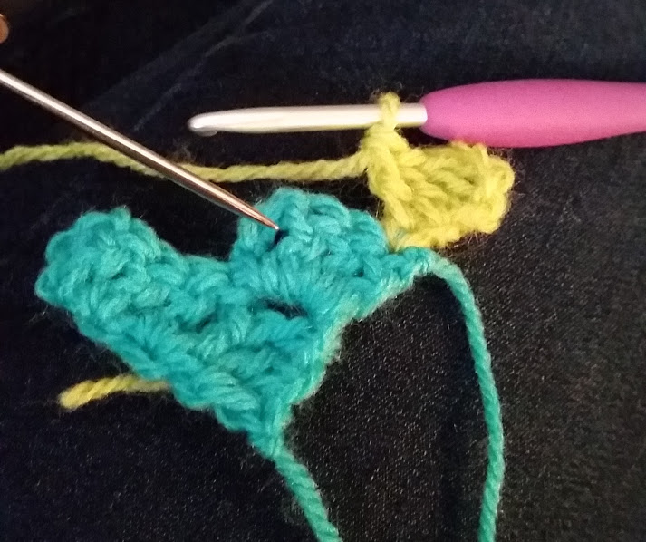
*Ch 3 and work 3 more tr into the same space between posts*

Ss into the space between the end posts on the next grouping and work again as per ** above

Turn and chain 6. Tr into the 4th ch from the hook and the next 2 ch.

**Ss into the next grouping. Ch 3 and work 3 more tr into the same space between posts**

Repeat between **&** to the end

Either continue with a ch 6 if using a continuous method or cast off, turn and join with a new colour with a ch 6.

Continue working this pattern as your blanket grows until it is as wide as you want it to be. You will then need to decrease your work as follows:

You will need to make a mirror image of what you have just made, so this first row of decreasing will have the same number of blocks in it as the last row you just made.

Take a look at the picture below you will see 8 blocks. Make sure you crochet decrease blocks on top of each step right up to the top so there will be 8 blocks in the next row too:

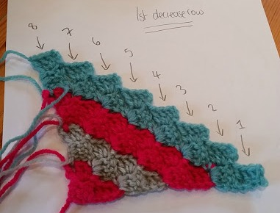

If you are using a continuous colour of yarn you will need to replace the chain 6 and ss across the top of your group until you reach the point marked with my needle (corner of the block marked 1 above)

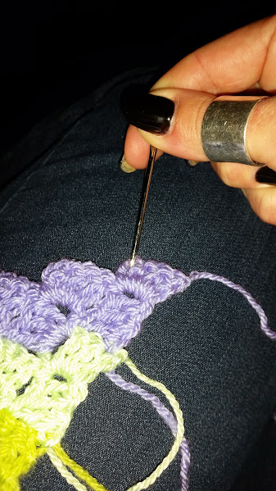

If you are changing colour you will need to join your new colour at this point and ch3. Then 3tr into the same space and continue your pattern along the work until you reach the end and turn.

Ss 3 times across the top of the group to the next end space between pillars. Ch 3 and continue with the pattern to the end of the row. Continue to repeat this decrease method getting smaller with each row until you reach the end of your blanket

