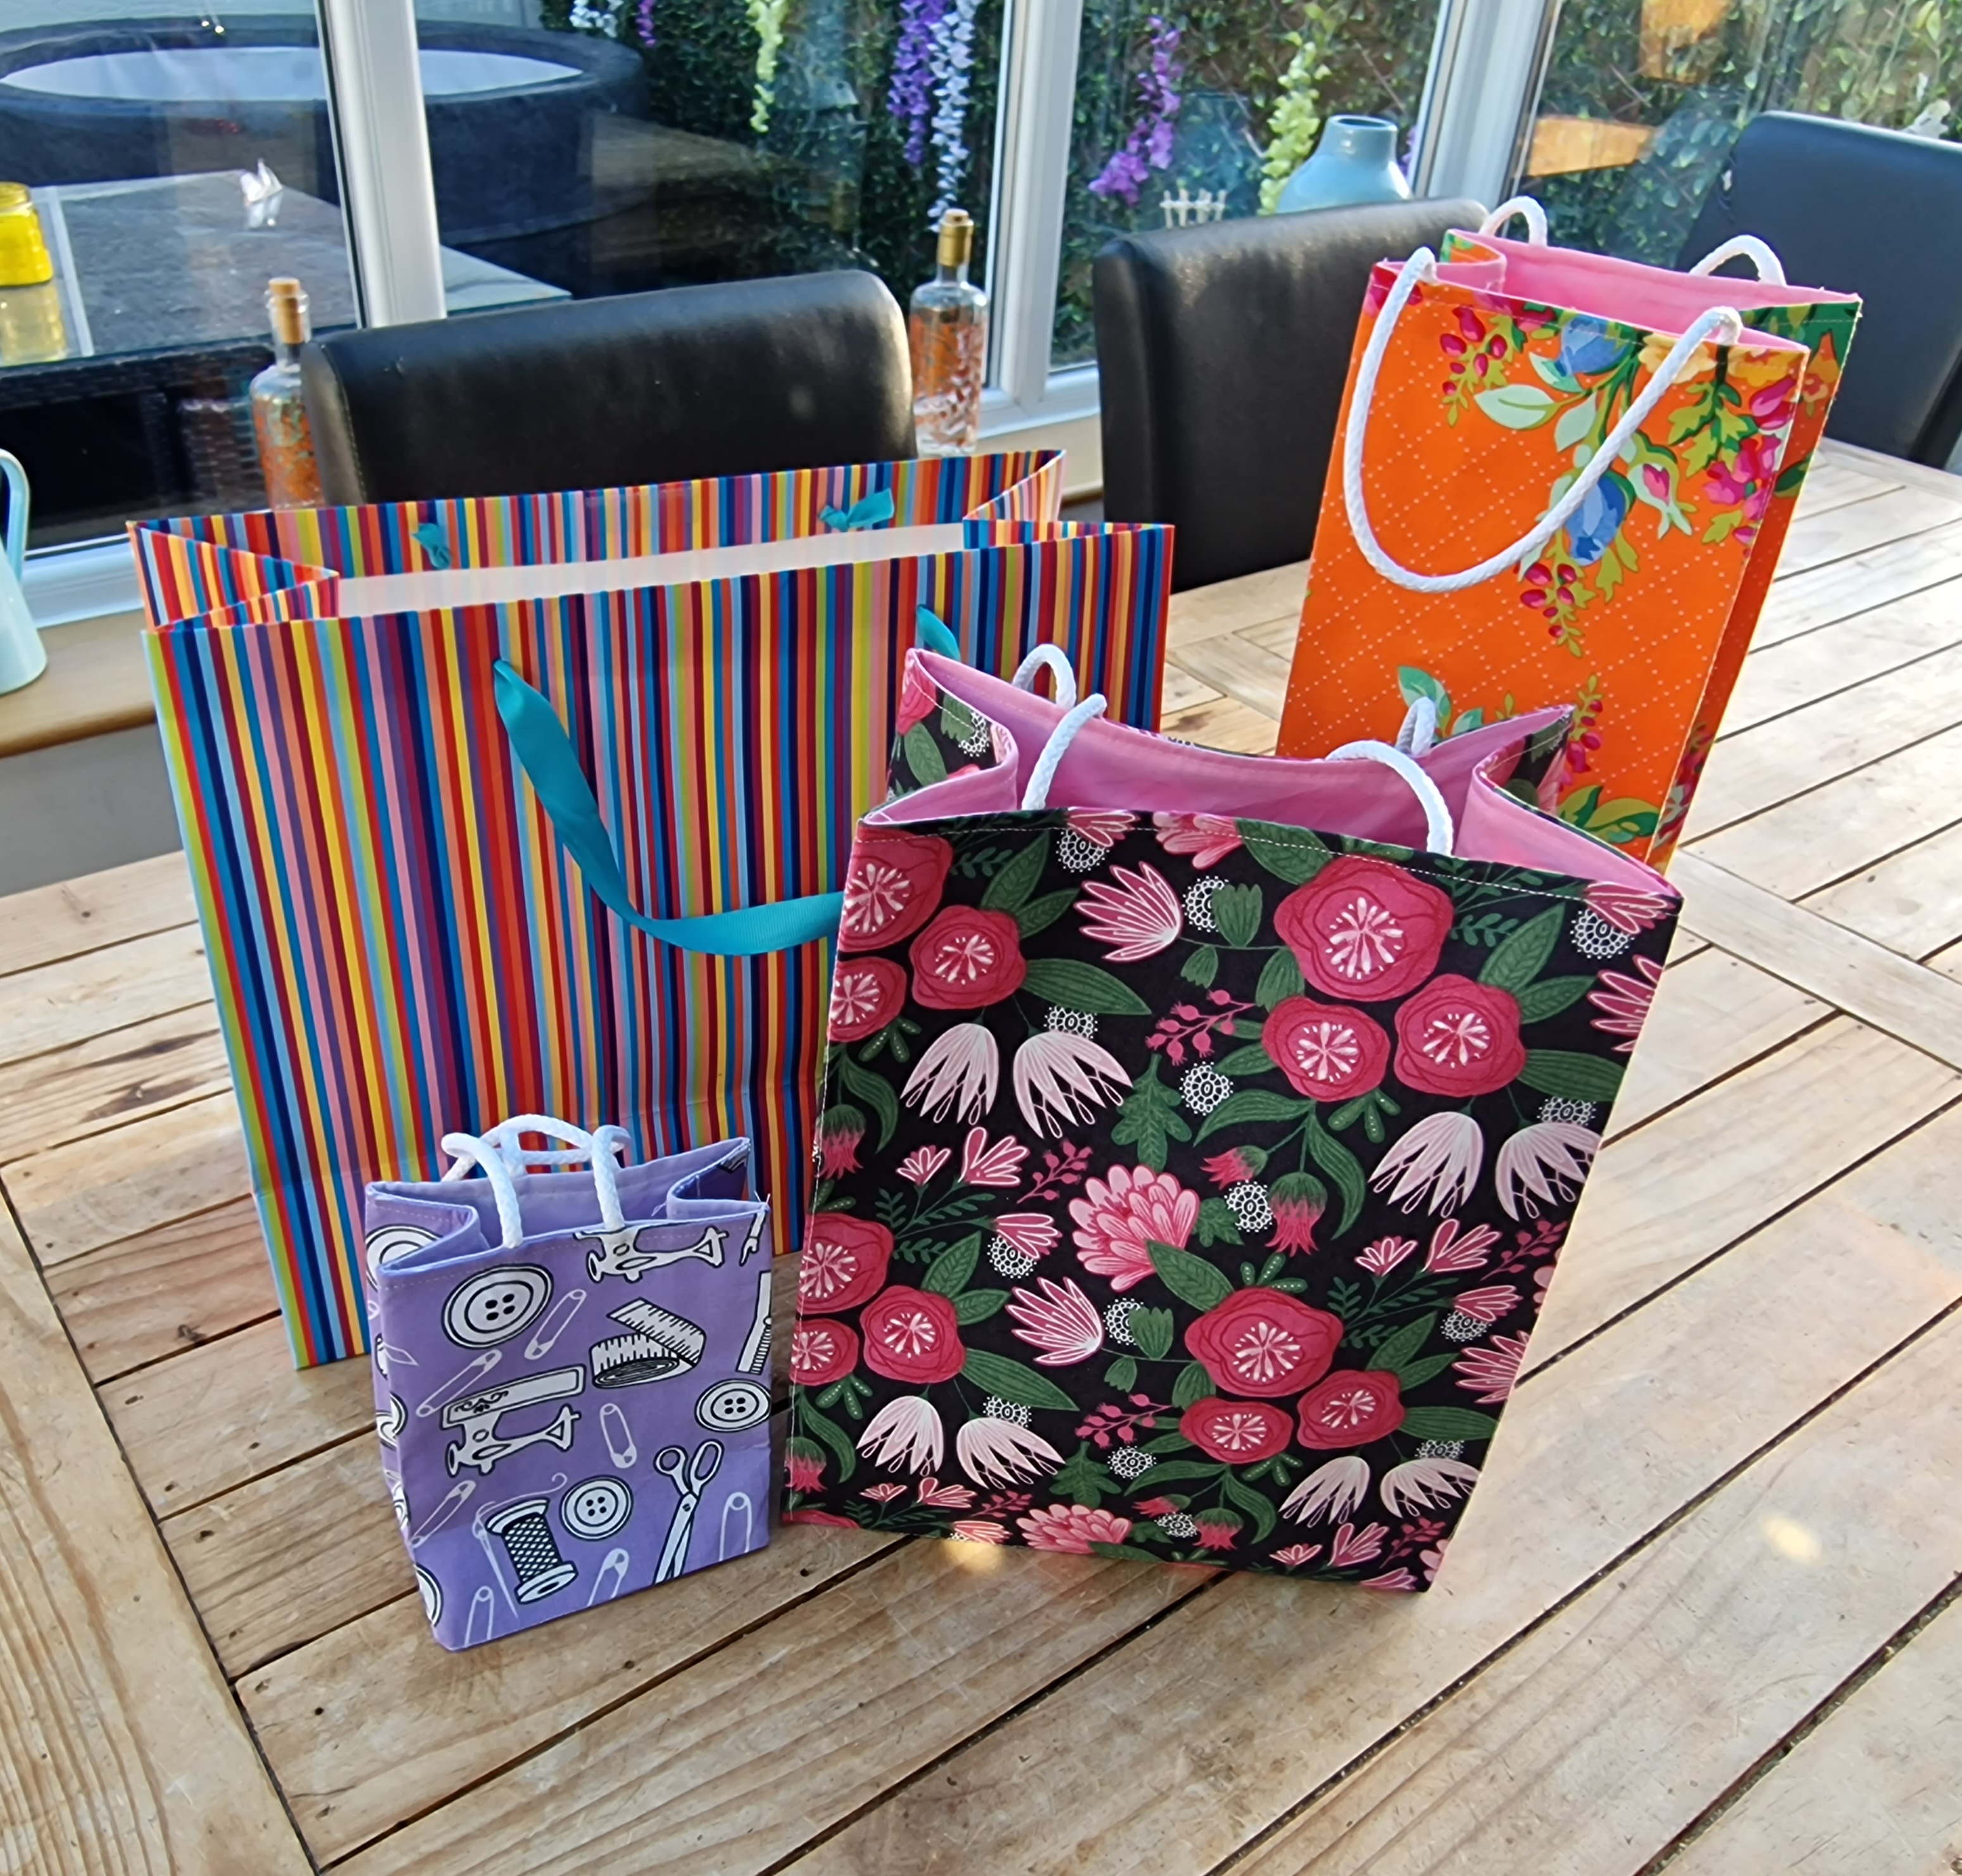


Fabric (Paper) Bags

Step 1

Take your chosen size of paper gift bag and cut down the side centre seams and along the base to the corners on both sides. Open out flat

Step 2

Draw around your bag onto a piece of heavy weight fusible interfacing. Also draw on the side fold lines and the base fold lines. Mark the handle placement.

Step 3

Fuse to the wrong side of your fabric. Add a ¼” seam allowance and cut out.

(If you are using directional fabric, fold along the base section and cut into 2 separate sides. Fuse to the wrong side of your fabric ensuring the top edges are the correct way up on your design. Add ¼” seam allowance to the base and sew right sides together. Press open and continue to step 4)

Step 4

Sew along the side lines your drew onto the interfacing. (These will help you press the bag into shape when it’s finished).

Step 5

Lay the finished flat piece onto some plain cotton for your lining and cut out.

Step 6

Cut cord handles and baste in place on the outer bag

Step 7

Sew up both side seams on the outer and then nest the bottom corners and sew closed.

Repeat with the lining but leave an opening in 1 side to turn

Step 8

Turn outer in the right way and post inside the lining with handles down. Sew around the top edge.

Step 9

Turn through the opening in the side, check all is well and then close the hole with a narrow seam allowance

Step 10

Press all folds to within an inch of their life with a lot of steam.

TA DA!!! A finished Fabric (Paper) bag.

