Market Trader/ Garden Apron

Materials required:

This will greatly depend on the fabrics you choose. If you wish to make your entire apron from the same fabric you will require 2 metres.

Otherwise please look at the dimensions of each piece and our diagram to determine requirements before purchasing.

Cutting Guide:

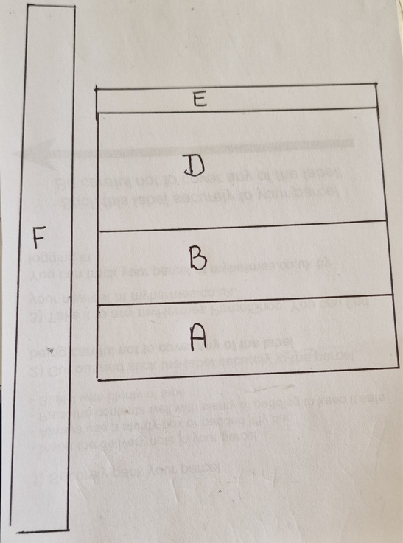

A = Front pocket, Cut x 1 outer & Cut x 1 lining
(16.5” x 6”)
B = Mid pocket, Cut x 1 outer & Cut x 1 lining
(16.5” x 10”)
D = Main & Back, Cut x 1 outer & Cut x 1 Backing
(16.5” x 15.5”)
E = Waist band Cut x 1
(19.5” x 6”)
F – Ties Cut x 2, from same fabric as waist
(58” x 6”)

Instructions:

1) Create pockets A & B by placing fabrics RST and sewing along the top edge. Press seam allowances open and fold WST. Add binding or trim to top edge if desired.

2) Lay pockets over main outer (D) and Baste down sides with a narrow seam allowance to hold in place.

3) Mark and stitch any additional dividing pockets onto piece A at this point.

4) Lay finished front RST with back (D) and sew down both sides and along the bottom with a ¼” seam allowance.

5) Clip bulk from corners and turn in the right way, press well.

6) Sew ties RST either side of waist panel and press seams open

7) Turn both long edges ½” to the wrong side and press. Then press length of strap WST.

8) Open up both ends of ties and sew RST, clip the corner and turn back out to WST

9) Sandwich top edge of apron into the waist seam and pin centrally in place with the top edge of the apron touching the fold of the waist.

10) Top stitch down the open edge of the tie from 1 end to the other, sewing the apron in as you go.

11) Repeat step 8 along the folded edge of the tie and waist to secure apron front in.

